**Model Development Phase**

|  |  |
| --- | --- |
| **Date** | 17 June 2025 |
| **Team ID** | SWTID1749876754 |
| **Project Title** | SynapseScan: AI Driven Classification of Ovarian Cancer Variants |
| **Maximum Marks** | 4 Marks |

**Initial Model Training Code, Model Validation and Evaluation Report**

The initial model training code will be showcased in the future through a screenshot. The model validation and evaluation report will include classification reports, accuracy, and confusion matrices for multiple models, presented through respective screenshots.

**Initial Model Training Code:**

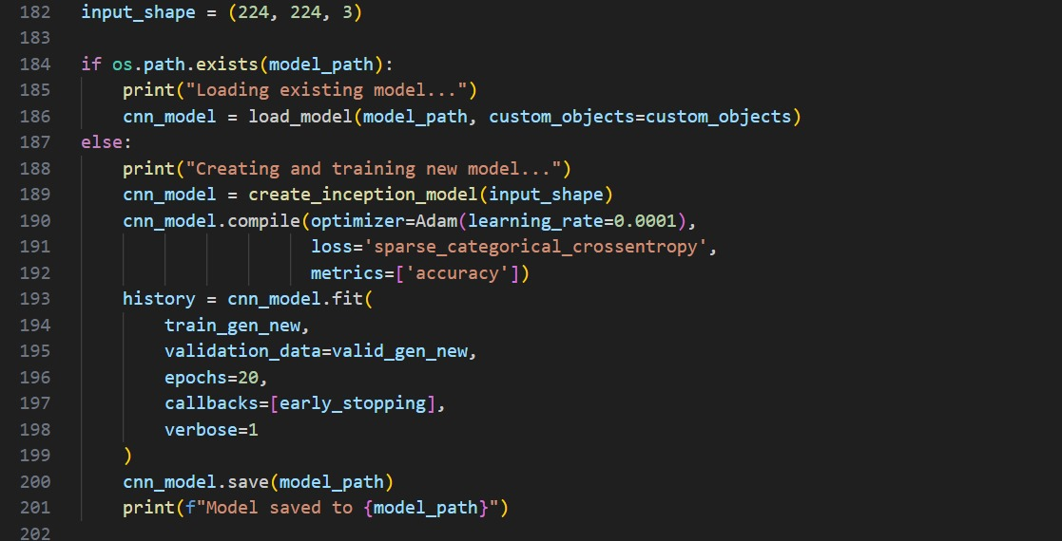

**Model Validation and Evaluation Report:**

|  |  |  |  |
| --- | --- | --- | --- |
| **Model** | **Classification Report** | **F1 Score** | **Confusion Matrix** |
| InceptionV3 + Attention + Fine-tuning |  | 93.84% |  |
| InceptionV3 +Attention |  | 77.34% |  |
| MobileNet + Fine-tuning |  | 36.21% |  |